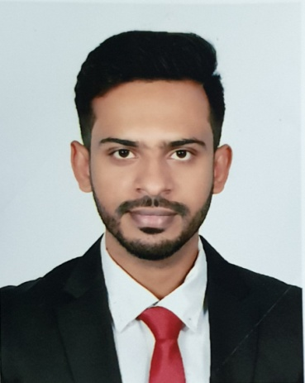

**ShahariaRahman Khan**Mia Monzil, Yeakub Ali Sardar Road,

Sagardi, Dargabari, Barishal.

01711998605

www.com_bd@yahoo.com

**Career Objective :**

* Employment in the areas of socio-infrastructure development, Administration, any reputed national & abroad in any challenging sector.
* Work in dynamic, challenging, multi-culture & disciplined environment.

**Work Experience**

* Work With TVS Auto Bangladesh Ltd as a Executive 02 November 2019 to till now.
* Work With Trust Bank Ltd (t-cash) as a territory Officer 01 October 2018 to 31 October 2019.
* Work With**Asiatic Exp as a Regional co-ordinator** GrameenPhone Project 01 September 2015 to 30 September 2018.

**Bachelor Of Business Administration (BBA)**

Name of Subject : Management

Name of Institution : Govt. B.M College, Barisal.

Establishment : National University.

Year of Passing : 2016

Result : CGPA 3.04

**Higher Secondary certificate (HSC)**

Name of group : Business Studies

Name of Institution : Govt. Syed Hatem Ali College,Barishal.

Establishment : Barisal Board

Year of Passing : 2012

Result : G P A 4.40

**Secondary School certificate (SSC)**

Name of group : Business Studies

Name of Institution : Udayan High School,Barishal.

Establishment : Barisal Board

Year of Passing : 2010

Result : G P A 4.13

**Skills**

**Computer**: MS Word, MS Excel, MS Power Point, Internet using, video editing

**Communication:**

* Good Communication skills in Bangla & English.
* Good Communication skill & Ability to maintain good inter personal relationship.
* Good organizing & management capacity.

**Personal Affairs**

Name : ShahariaRahman Khan

Father’s Name : Md. HabiburRahman Khan

Mother’s Name : SyedaMoriom Begum

Date of Birth : 06 September 1995

Place of Birth : Barisal

Marital Status : Single

Nationality : Bangladeshi (by birth)

Religion : Islam (Sunni)

High : 5’-10’’

Permanent Address: Mia Monzil, Yeakub Ali SardarRoad,Sagardi, Dargabari, Barishal.

**Reference:**

**Mir Abu Sayem**

Assistant vice president

Agent Banking Division

The City Bank Ltd.

Cell : 01711504842

**__________________________**

**ShahariaRahman Khan**